**Name: vijay vishnu p b**

**Roll No:49**

**Batch: mca b**

**Date:19-04-22**

**ADVANCED DBMS LAB**

**Experiment No.: 4**

**Aim**

To familiarize with aggregate functions

**QUESTION**

**1.List total loan**

select sum(amount) from borrow;

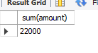

**2.List total deposit**

select sum(amount) from deposite;



**3.List total loan taken from KAROLBAGH branch**

select max(amount) from borrow where bname='karolbagh';

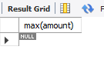

**4.List total deposit of customers having account date later than 1-Jan-96**

select sum(amount) from deposite where adate>'1995-03-01';



**5.List total deposit of customers living in city NAGPUR**

select sum(d1.amount) from deposite d1, customer c1 where c1.city='nagpur' and c1.cname = d1.cname;



**6.List maximum deposit of customer living in Bombay**

select max(d1.amount) from deposite d1, customer c1 where c1.city='bombay' and c1.cname=d1.cname;

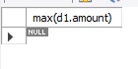

**7.List total deposit of customer having branch in BOMBAY**

select sum(amount) from deposite,branch where city ='bombay';

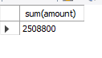

**8.Count total number of branch cities**

select count(distinct(city)) from branch;

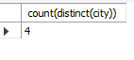

**9.Count total number of customers cities**

select count(city) from customer;



**10.Give branch names and branch wise deposit**

select bname, sum(amount) from deposite group by bname;

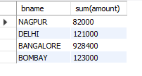

**11.Give city wise name and branch wise deposit**

select c1.city, sum(d1.amount) from customer c1,deposite d1 where d1.cname =c1.cname group by c1.city;

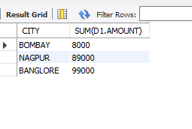

**12.Give the branch wise loan of customer living in NAGPUR**

select bname, sum(amount) from borrow,customer where city ='nagpur' group by bname;

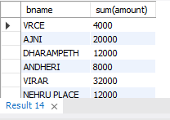

**13.Count total number of customers**

select count(cname) from customer

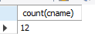

**14.Count total number of depositors branch wise**

select bname,count(*)from deposite,customer where deposite.cname=customer.cname group by bname;

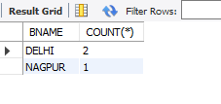

**15.Give maximum loan from branch VRCE**

select max(amount) from borrow where bname='vrce';

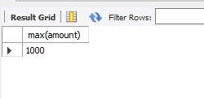

**16.Give the number of customers who are depositors as well as borrowers**

select count(distinct (cname)) from customer where cname in ((select cname deposite) in (select cname from borrow));

